Alaska Indoor Gardening Curriculum
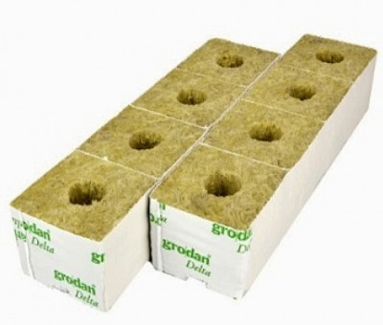

Hydroponic Growing Media
Author: Melissa Sikes, Alaska Ag in the Classroom

Suggested Grade Levels: 3-12th grade

Time: 45 minutes – 1 Hour

Teaching Goal:
To introduce students to the different types of hydroponic grow media to help them learn how they help the plant grow.

Learning Objectives:
Students will explore the different types of media, and will test their water retention and filtration. Students will understand the difference between the different types of media and why they are used and how they differ from soil.

Core Topics:
- Hydroponic Systems
- Plant Dynamics (circulation and nutrient uptake)
- Growing Media (soil, water, other)
- Recording Scientific Data in Tables
- Standardized Science Measurements
- Drawing Conclusions from Experimentation (hands-on, observation, and note-taking)

Alaska Science Standards: 3-5-ETS1-2, 4-LS1-1, 4-PS3-4, 5-PS3-1, 5-LS1-1, 5-LS2-1, MS-LS2-1, MS-LS2-4, MS-LS2-5, MS-ESS3-3, MS-ETS1-2, HS-ESS3-4

NGSS Standards: 3-LS1-1, 3-LS4-4, 4-LS1-1, 5-LS1-1, 3-5-ETS1-2, MS-LS1-5, MS-LS3-3, MS-ESS3-3, MS-ETS1-1, HS-LS1-3, HS-LS2-6, HS-ESS2-6, HS-ESS3-4, HS-ETS1-3

Materials Needed
- Examples of different growing mediums including: rockwool, vermiculite, perlite, pea gravel, sand, hardwood sawdust, peat moss, and styrofoam
- Potting soil samples
- Samples of soil from a local garden
- Magnifying glasses
- Paper plates
- Scissors
- Pencils
- Clear plastic cups
- 1 cup measuring cups, 1 per group
- Small bowls
- Small scales; food scales work well
- Pitcher and water
- Sharpie markers
- Timers
- Grow medium investigation worksheet

Vocabulary:
- Chemically Inert: is used to describe a substance that is not chemically reactive. In hydroponics, it means it won’t react with the components of the nutrient solution.

- Grow Medium: Growing media are materials that plants grow in. Growing media is specifically designed to support plant growth and can either be a solid or a liquid.

- Hydroponics: The cultivation of plants by placing the roots in liquid nutrient solutions
rather than in soil; soilless growth of plants.

- Porous: Having many pores or other small spaces that can hold a gas or liquid or allow it to pass through.

- Sterile: something totally clean and free from bacteria or other microorganisms.

- Water Retention: is a measure of how much water a particular type of soil or grow medium can retain.

Background for Teachers:

Hydroponic media refers to the substance that supports the plant, that the roots grow into. There are major characteristics that the substance used must have:
- Chemically Inert: The substance must not react with the nutrient compound or acids in the hydroponic solution. This is very important in recirculating systems.

- Water Retention: The substance must be able to drain water yet retain enough water to support the plants. Two factors that can determine this are capillary action and the percentage of liquid to solid weight after draining.

- Uniform size of particles or fibers: The actual size needed depends on the type of plant and the climate of the room or location. The particle size affects how much air can get to the roots; they must have access to available oxygen.

- Sterility: Media should be free from harmful parasites, fungi, and insects. The quality of sterility is very important for seedlings and propagated cuttings. Larger plants are not very sensitive, but fungus and viruses can drastically reduce yields.

- Weight: Using light and easy to move media is one of the benefits of hydroponics, reducing labor time and cost.

Types of Hydroponic Grow Media

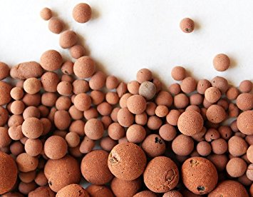
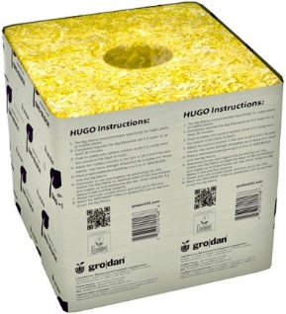
Rockwool
Rockwool is one of the most common growing media's used in hydroponics. Rockwool is a sterile, porous, non-degradable medium that is composed primarily of granite and/or limestone which is super-heated and melted, then spun into a small threads like cotton candy. The rockwool is then formed into blocks, sheets, cubes, slabs, or flocking. Rockwool sucks up water easily, so you'll want to be careful not to let it become saturated, or it could suffocate your plants roots, as well as lead to stem rot and root rot. Rockwool should be pH balanced before use. That's done by soaking it in pH balanced water before use. It comes in various shapes and sizes.
Clay Aggregate
Clay aggregate is a type of clay which is super-fired to create a porous texture. It's heavy enough to provide secure support for your plants, but still light weight. Clay aggregate is a non-degradable, sterile growing medium that holds moisture, has a neutral pH, and also will wick up nutrient solution to the root systems of your plants. Clay grow media is reusable, it can be cleaned, sterilized, then reused again. Although on a large scale, cleaning and sterilizing large amounts of grow rocks can be quite time consuming. Clay aggregate is one of the most popular growing medium used for hydroponics, and just about every store selling hydroponics supplies carries it.
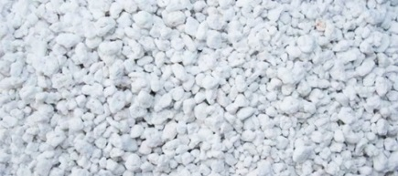
Perlite
Perlite is mainly composed of minerals that are subjected to very high heat, which then expand it like popcorn so it becomes very light weight, porous, and absorbent. Perlite has a neutral pH, excellent wicking action, and is very porous. Perlite can by used by itself, or mixed with other types of growing media. However, because perlite is so light that it floats, depending on how you designed your hydroponic system perlite by itself may not be the best choice of growing media for flood and drain systems.
Perlite is widely used in potting soils, and any nursery should carry bags of it. However perlite is sometimes also used as an additive added to cement. When working with perlite be careful not to get any of the dust in your eyes. Rinse it off to wash out the dust and wet it down before working with it to keep the dust from going airborn.
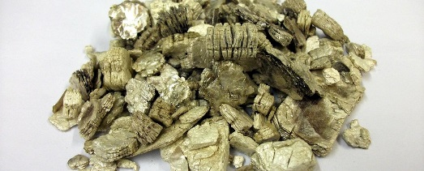
Vermiculite
Vermiculite is a silicate mineral that, like perlite, expands when exposed to very high heat. As a growing media, vermiculite is quite similar to perlite except that it has a relatively high cation-exchange capacity, meaning it can hold nutrients for later use. Also, like the perlite, vermiculite is very light and tends to float. There are different uses and types of vermiculite, so you'll want to be sure what you get is intended for horticulture use. The easiest way to be sure is to get it from a nursery.

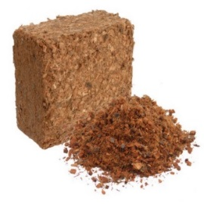
Coco Fiber
"Coco coir" (Coconut fiber) is from the outer husk of coconuts. What was once considered a waste product is one of the best growing mediums available. Although coco coir is an organic plant material, it breaks down and decomposes very slowly, so it won't provide any nutrients to the plants growing in it, making it perfect for hydroponics. Coco coir is also pH neutral, holds moisture very well, yet still allows for good aeration for the roots. Coco fiber comes in two forms, coco coir (fiber), and coco chips. They’re both made of coconut husks, the only difference is the particle size. The coco fiber particle size is about the same as potting soil, while the coco chips particle size is more like small wood chips.
The larger size of the coco chips allows for bigger air pockets between particles, thus allowing even better aeration for the roots. Also if your using baskets to grow your plants in, the chips are too big to fall through the slats in the baskets. Both the fiber and chips come in compressed bricks and once soaked in water it expands to about 6 times the original size. Coco fiber does tend to color the water, but that diminishes over time. And, you can leach out most of the color if you soak it in warm/hot water a few times before use.
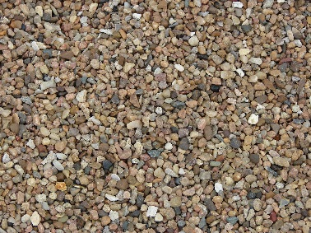
Pea Gravel:
Pea gravel is gathered commercially from riverbeds and is run through a screening process to assure particle size uniformity. The best type is composed of igneous rock such as granite. It is nearly inert. Hydroponic grade gravel has been washed and is free of insects and active fungi, but may include spores. This medium is commonly used in flood and drain systems where the roots are flooded completely, then drained completely once to six times per day. Each time the water drains, fresh air flows into the spaces between the gravel.

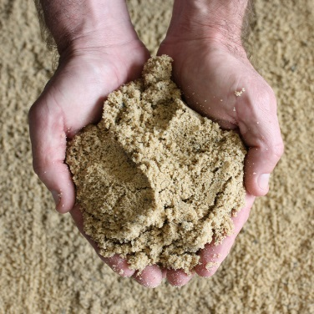
Sand
Sand Is actually a very common growing media used in hydroponics. Because the particle size is smaller than regular rock, moisture doesn't drain out as fast. Sand is also commonly mixed with vermiculite, perlite, and/or coco coir. All help retain moisture as well as help aerate the mix for the roots.
When using sand as a growing media you will want to use the largest grain size you can get. That will help increase aeration to the roots by increasing the size of the air pockets between the grains of sand. Mixing vermiculite, perlite, and/or coco coir with the sand will also help aerate. You will also want to rinse the sand well before use to get as much of the dust particles out of it as you can. One big downside to using sand as a growing media for hydroponics is that it is very heavy. Three to four gallons of wet sand can weigh up to 50lbs. So you won't want to be moving it once you get it set up. Or, use it in a ratio of something like 20%-30% sand and the rest vermiculite, perlite, or another type of growing media to reduce weight.
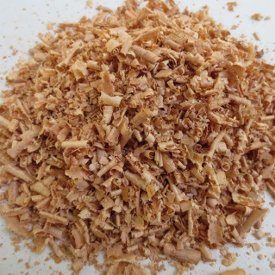
Wood Shavings or Sawdust
Fresh wood waste is rarely used as a stand-alone growth medium, although it may serve as a rooting medium for cuttings. Usually it forms a constituent (normally less than 50%) in mixtures. Sawdust has been the standard growing medium for the greenhouse industry in Alberta for several decades. Sawdust can be used, but it should be from a known source. You don't want sawdust that contains paint, varnish or any other chemicals.

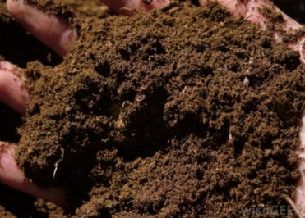
Peat Moss
Peat moss is often used for seedling starting, in potting mixes, and even as a primary hydroponic or aquaponic media. Hobby growers and commercial growers both use peat for its great water holding capacity, a slight acidity that makes pH adjustments easier, and the low cost (about $40 per cubic yard). Peat is not appropriate for all hydroponic systems, however. Once it starts to decompose, it compresses around the roots, which are choked out in the anaerobic root zone. You can balance this effect to some degree by adding more structure to the medium. It’s a good idea to mix peat moss with something else – perlite (not for aquaponics, though!), or even coco coir. This aerates the mix and helps avoid compression.
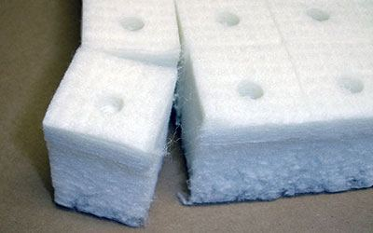
Styrofoam
Polystyrene-foam-plastic can be used as a growth medium if soaked for 3 to 4 weeks in water before planting and rinsed at least twice before use to avoid toxic gas effects. The lower 2/3 of the beds are filled with foam plastic and the upper 1/3 with gravel, to weigh down the plastic. 2 1/% of plastic is lost by each uprooting. Floral Foam is also a good type of styrofoam to use.

Procedure:
- Discuss the difference between grow media, potting soil, and garden soil. Have plates of samples of each medium including the potting soil and garden soil to show. Discuss why sterile media and disease free substrate are important to hydroponic systems. Discuss the advantages of water retention and why it is important to plant growth.

- Pass out samples of grow mediums and the garden soil and potting soil on paper plates. Be sure to label and tell students not to mix together.

- Split the students into small groups.

- Have students investigate the different grow mediums. Ask them to feel each medium for its texture and look at it with the magnifying glass.

- Have them write down their observations on the worksheet.

- Pass out three clear plastic cups to each student group. Have the students measure out one cup of water into one of the clear plastic cups. Mark the level with a sharpie on the outside of the cup so they can use cup as a measuring tool again and again.

- Have students poke a hole in the other cup with a sharp pencil or scissor.

- Then add one cup (or approximately one cup as rockwool and styrofoam are hard to measure this way) of one type of grow medium to the cup with the hole in it. Mark the level of the sample on the cup with the sharpie.

- Have them weigh the cup and medium on the scale and write down the weight before adding the water on the chart.

- Have them measure out one cup of water. Have them slowly pour the measured cup of water through the sample of the growing medium cup over a bowl. Have them wait at least three 3 minutes, use the timer. Have them note how much the medium has changed its level, if any. Weigh the cup with the medium in it again. Note and estimate a measurement of how much water passed through into the bowl. This process will test how the different media hold water.

- Then, have them mix a couple different types of mediums and then experiment with the mixtures. Have the students take notes on this or form a graph of the different types of media.

- Ask them which medium they think is the best and why? Ask them why they think some mediums may work better than others. Extend their thinking by asking which medium might work best for different types of plants. For example, a succulent may not thrive in a medium that retains a lot of water, but “thirsty” plants, like leafy greens, may. This could be an interesting discussion about plant requirements and preferences with your students.

Extensions: Setting up the Floating Hydroponic System, Plant Processes Lesson. Plant Growth and Needs Lesson, Chemistry in Plant Growth and Needs Lesson. Other ways to extend this lesson is to have students use standard units of capacity to measure the water going into the medium and the water going out. They can weigh the water, find the volume, etc. Grade levels working on metric units might find this practical application especially useful. Teachers could also consider extending this into a writing lesson, asking students to journal about their discoveries in their science journals, or consider comparing the different growth medias.

Assessment: Students can describe the positives and negatives of each of the different grow mediums. Chart is filled out with detail.

References:
Books
Gardening Indoors with Soil and Hydroponics
by George Van Patten 2007 ISBN: 978-1-878823-32-8

How to Hydroponics by Kenneth Roberto
ISBN: 0-9672026-1-2 2014

Hydroponic Basics: The Basics of Soilless Gardening Indoors
by George F. Van Patton 2004 ISBN: 978-1-878823-25-0

Hydroponics: A Complete DIY Guide for Gardening Using Simple Steps
by Allen Dunn 2012 ISBN: 9781480236141

Websites:
Foothill Hydroponics: http://www.foothillhydroponics.com/

General Hydroponics: http://generalhydroponics.com/

Hydroponics: https://hydroponics.com/

Institute of Simplified Hydroponics: http://carbon.org/

Simply Hydroponics and Organics: http://www.simplyhydro.com/system.htm

Uponics: http://uponics.com/hydroponic-tower/

Grow Medium Investigation

Name___________________________________________ Date____________

Investigate the growing media. Write down your observations about each one.

Weight Weight Amount of water
Type Before After remaining Observations

Conclusions:

